LAB ASSIGNMENT 14.4
Web Frontend Development – AI-Assisted HTML/CSS/JS Generation
Course: AI Assisted Coding
Course Code: 25CS002PC304
Assignment: 14

ALL AI PROMPTS
Prompt 1: Task 1: Responsive Homepage Layout for a Startup Website
You are an expert frontend developer. Create a responsive startup homepage using HTML, CSS, and JavaScript.
Requirements:
1. Create a header with navigation links.
2. Add a main content/hero section with a startup title, description, and call-to-action button.
3. Add a footer with basic information.
4. Use responsive CSS media queries so the layout works on mobile, tablet, and desktop screens.
5. Keep the code clean, semantic, accessible, and well structured.
6. Add comments explaining important CSS sections.
Return complete code that can be run directly in VS Code.

Prompt 2: Task 2: Interactive Call-to-Action Button
Create an interactive call-to-action button for a marketing webpage using HTML, CSS, and JavaScript.
Requirements:
1. Add a prominent button using HTML.
2. Use JavaScript to respond to a click.
3. Display a visible success/message response without reloading the page.
4. Add meaningful comments explaining the JavaScript logic.
5. Keep the implementation simple and readable.

Prompt 3: Task 3: Contact Form with Client-Side Validation
Create a contact form using HTML, CSS, and JavaScript with client-side validation.
Requirements:
1. Include fields for Name, Email, and Message.
2. Prevent submission when any required field is empty.
3. Validate the email using a suitable email pattern.
4. Display clear inline error messages.
5. Display a success message when all values are valid.
6. Validation must happen on the client side and should not reload the page.
7. Add comments explaining the JavaScript validation logic.

Prompt 4: Task 4: Dynamic List Management for a Product Page
Create a dynamic product list using HTML, CSS, and JavaScript.
Requirements:
1. Display an initial list of product items.
2. Add an “Add Item” button.
3. Add a “Remove Last” button.
4. When Add is clicked, append a new product item.
5. When Remove is clicked, remove the last product item.
6. Update the DOM instantly without refreshing the page.
7. Add clear comments to explain the JavaScript logic.

Prompt 5: Task 5: Modal Popup for User Notifications
Create a notification modal popup using HTML, CSS, and JavaScript.
Requirements:
1. Create an “Open Modal” button.
2. Build a modal containing a title, message, and close button.
3. Add a semi-transparent background overlay.
4. Use JavaScript to open and close the modal.
5. Allow the modal to close using the close button.
6. Also close it when the user clicks the overlay.
7. Add comments explaining the JavaScript logic.
8. Make the popup clear and responsive.

Task 1: Responsive Homepage Layout for a Startup Website
Topic / Task: Task 1: Responsive Homepage Layout for a Startup Website
Source requirements: This section follows the task requirements in Lab Assignment 14.4.
Code in VS Code
index.html
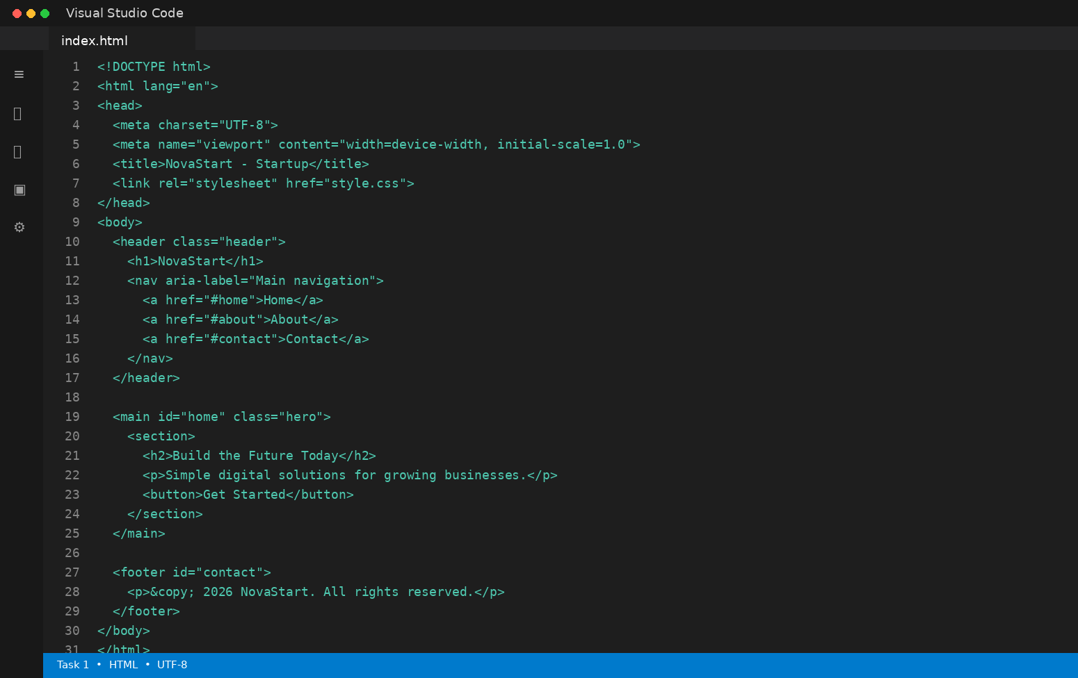
style.css
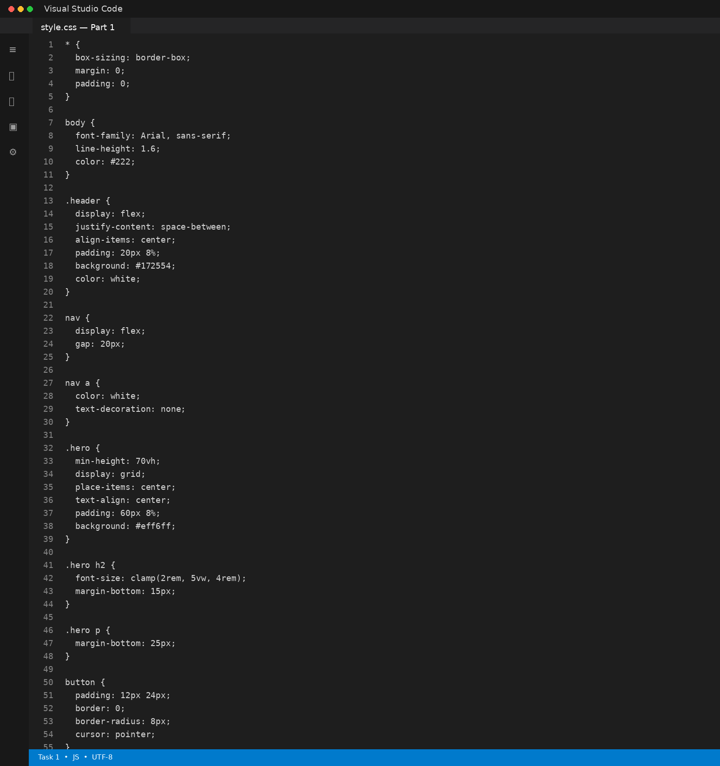
style.css — Part 2
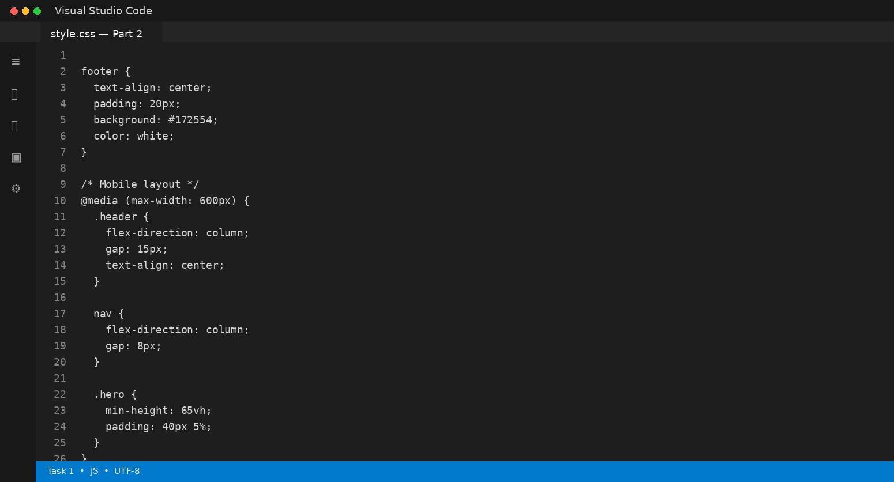
Code Explanation
The HTML provides a semantic header, navigation, main section, and footer. CSS Flexbox organizes the header and navigation, while a media query changes the navigation and spacing for smaller screens. The clamp() function also makes the heading scale smoothly.
Expected Output
A responsive startup homepage with clearly separated header, content, and footer sections that adapts to desktop, tablet, and mobile screens.

Task 2: Interactive Call-to-Action Button
Topic / Task: Task 2: Interactive Call-to-Action Button
Source requirements: This section follows the task requirements in Lab Assignment 14.4.
Code in VS Code
index.html
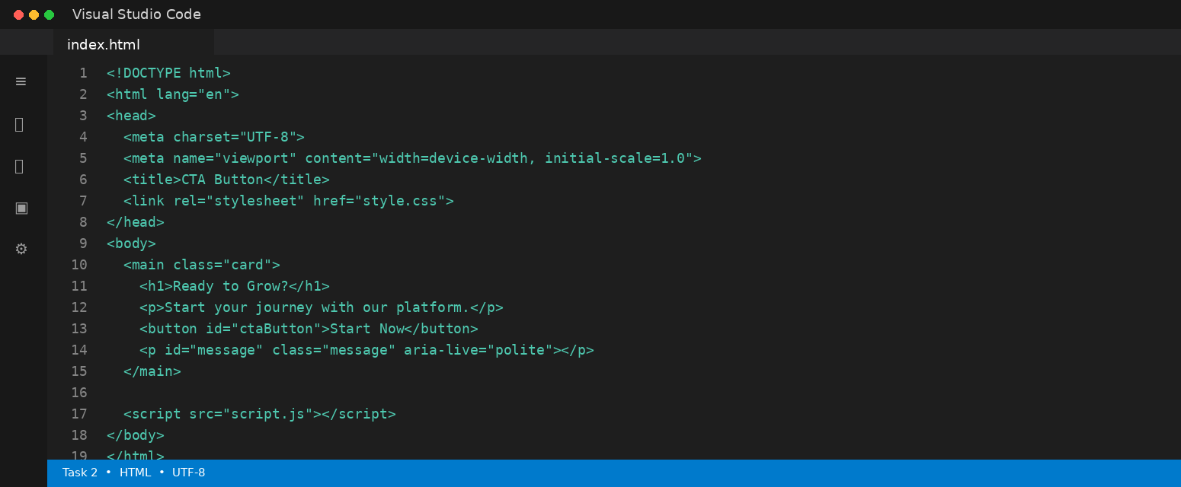
style.css
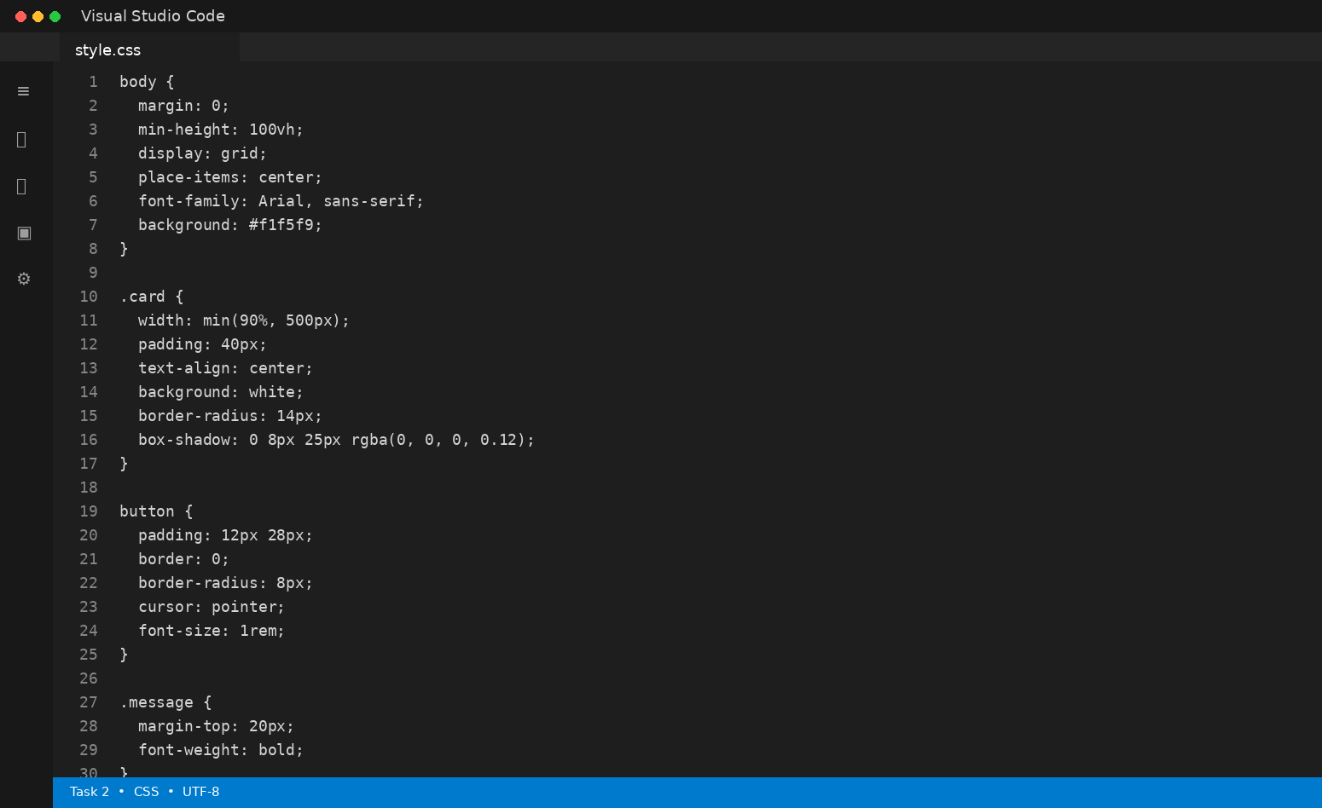
script.js
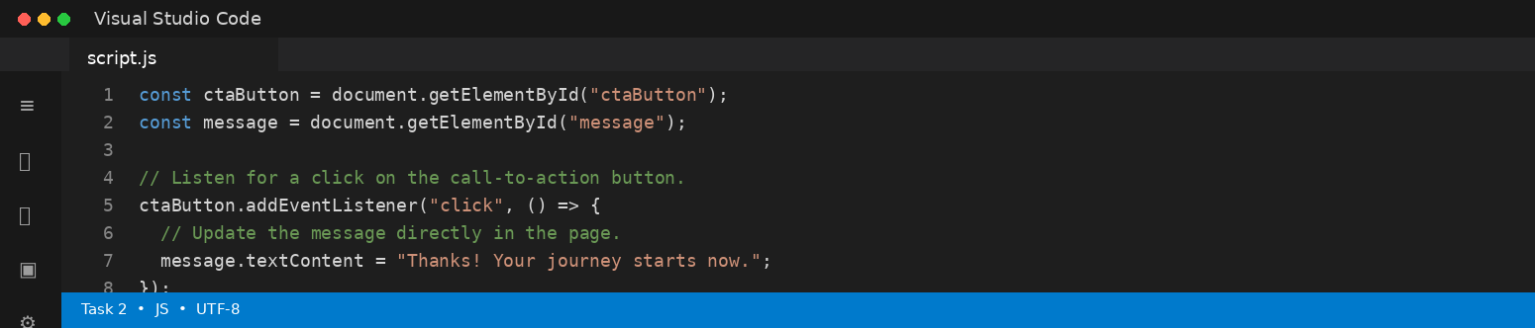
Code Explanation
JavaScript selects the button and message elements with getElementById(). An event listener waits for a click and then changes the textContent of the message element. Because the DOM is updated directly, the page does not reload.
Expected Output
When the user clicks “Start Now”, a visible confirmation message appears below the button without refreshing the page.

Task 3: Contact Form with Client-Side Validation
Topic / Task: Task 3: Contact Form with Client-Side Validation
Source requirements: This section follows the task requirements in Lab Assignment 14.4.
Code in VS Code
index.html
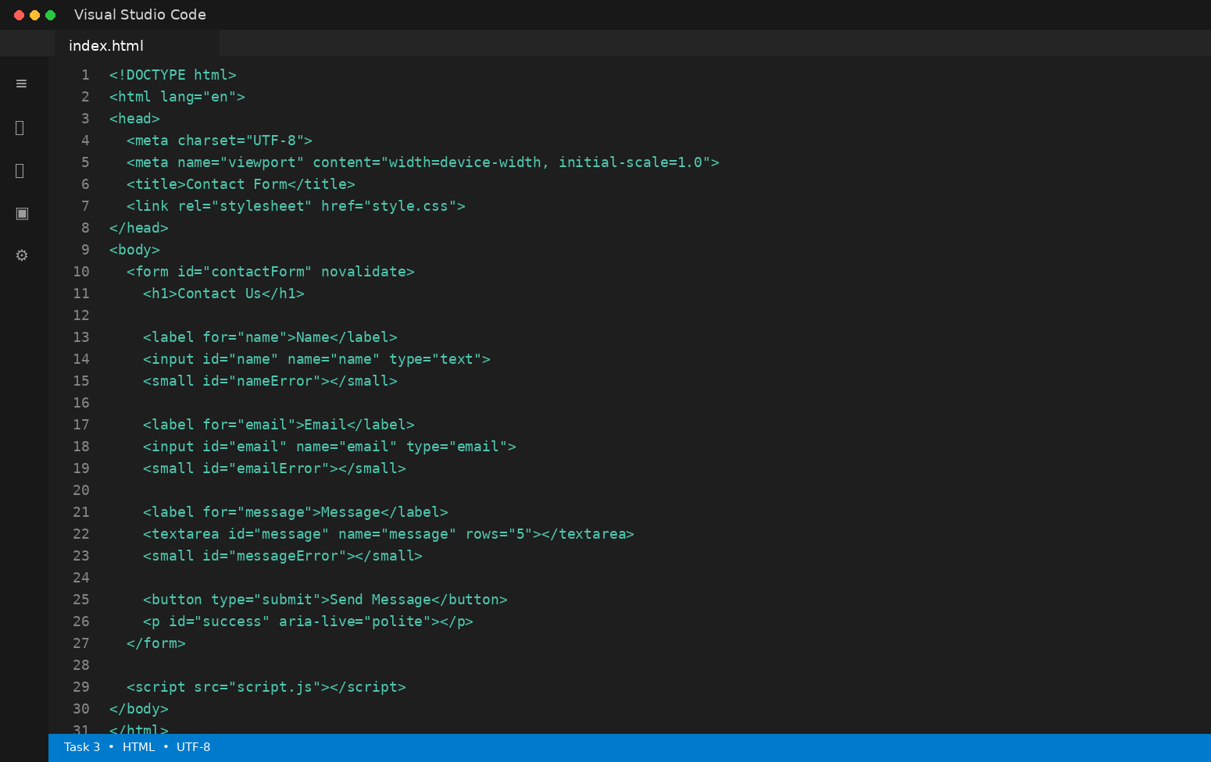
style.css
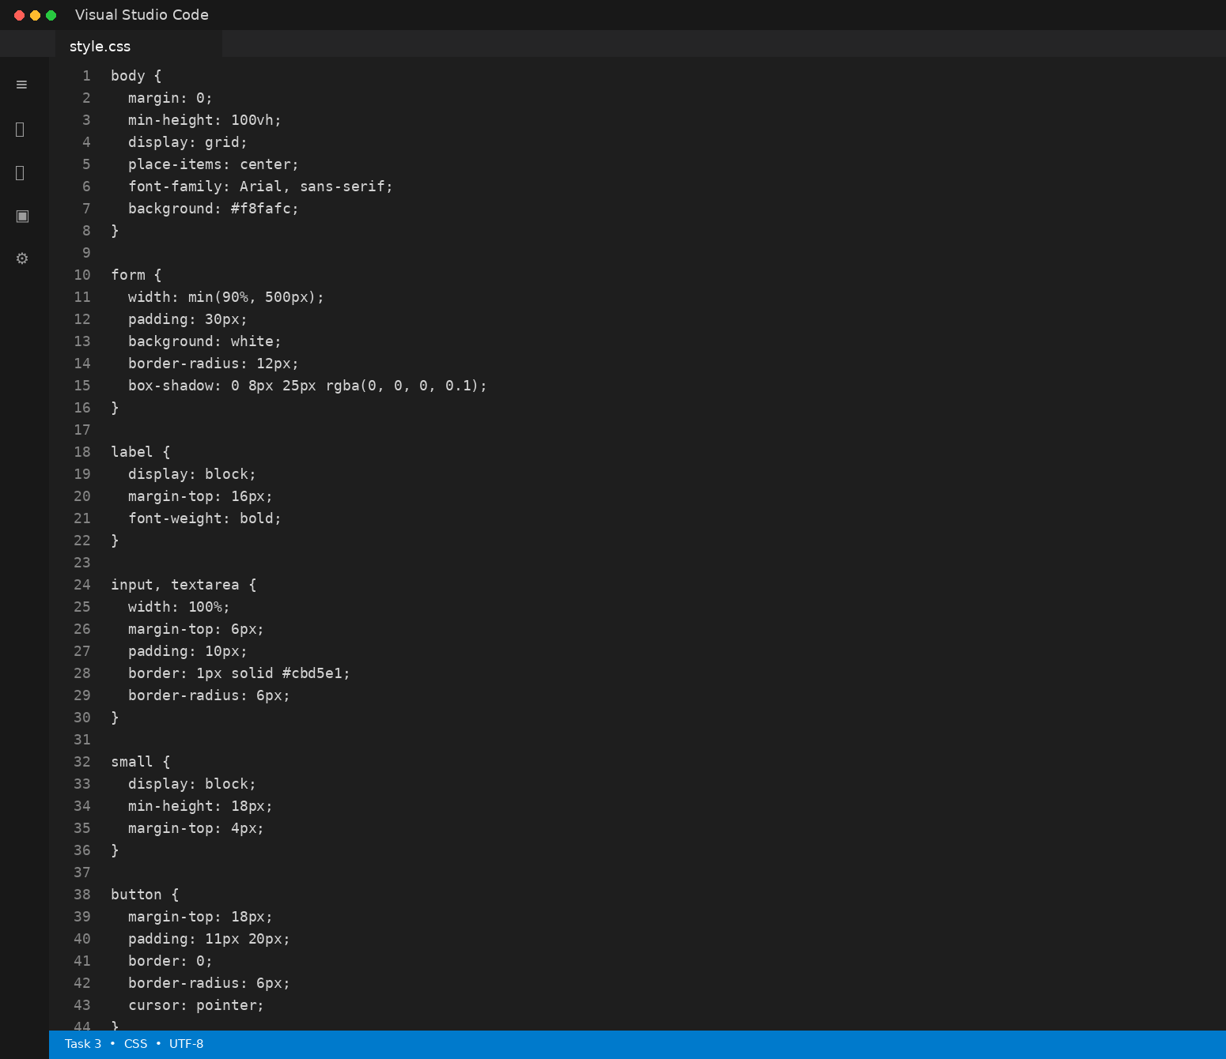
script.js
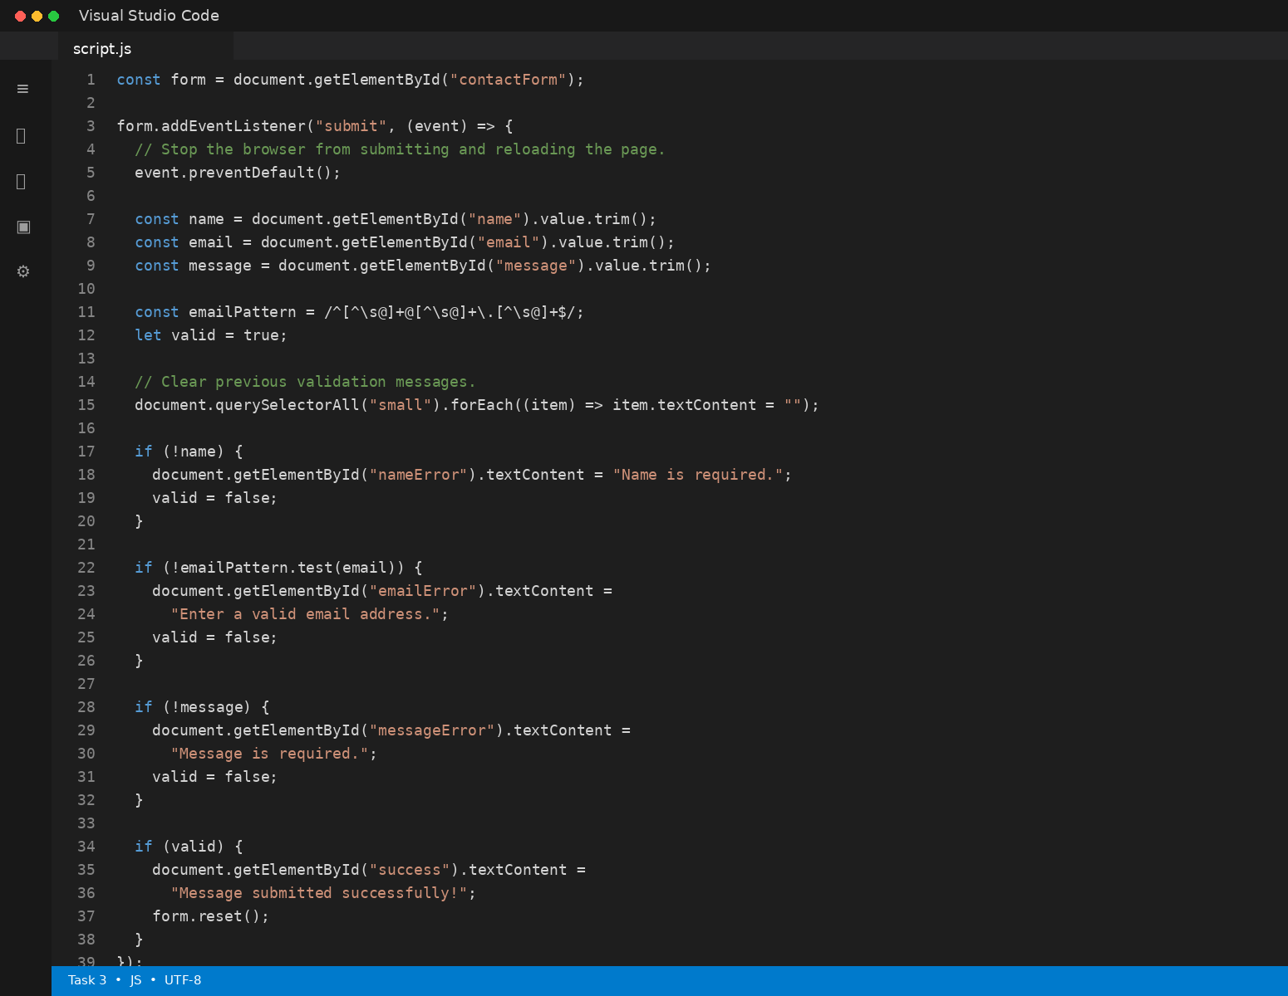
Code Explanation
The submit event is intercepted with preventDefault(), so the page does not reload. Each field is checked, and the email is tested with a regular expression. Errors are placed beside the relevant fields, while valid data produces a success message.
Expected Output
Empty or invalid fields show inline errors. When all fields are valid, the form displays a success message without a page reload.

Task 4: Dynamic List Management for a Product Page
Topic / Task: Task 4: Dynamic List Management for a Product Page
Source requirements: This section follows the task requirements in Lab Assignment 14.4.
Code in VS Code
index.html
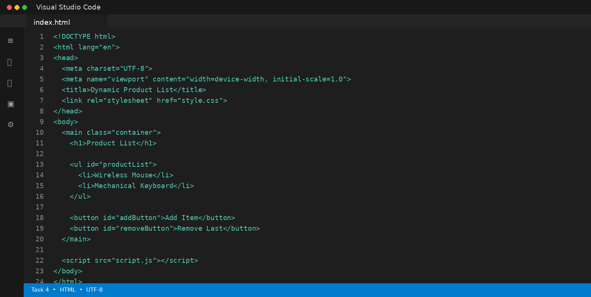
style.css
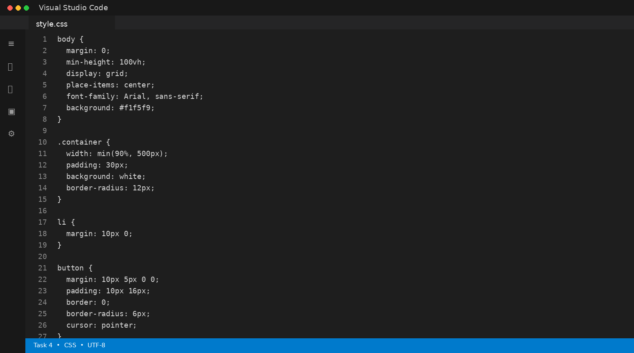
script.js
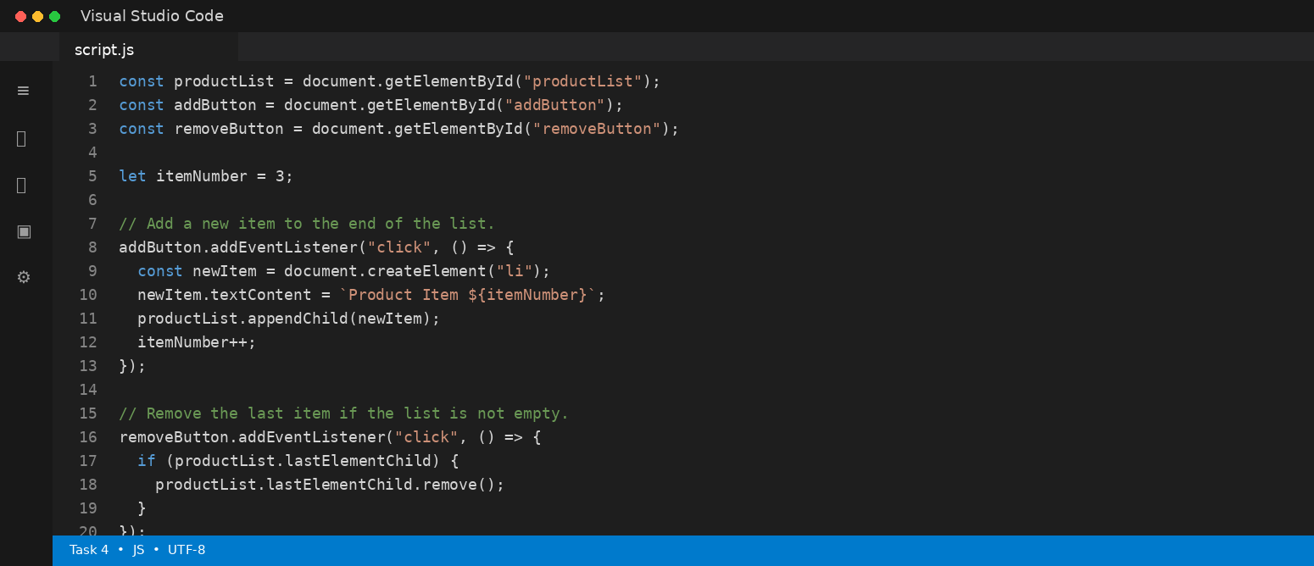
Code Explanation
The script uses createElement() to create a new list item and appendChild() to add it to the DOM. lastElementChild identifies the final item so remove() can delete it. All changes happen instantly without refreshing the page.
Expected Output
Users can add new products or remove the last product immediately, and the list updates dynamically.

Task 5: Modal Popup for User Notifications
Topic / Task: Task 5: Modal Popup for User Notifications
Source requirements: This section follows the task requirements in Lab Assignment 14.4.
Code in VS Code
index.html
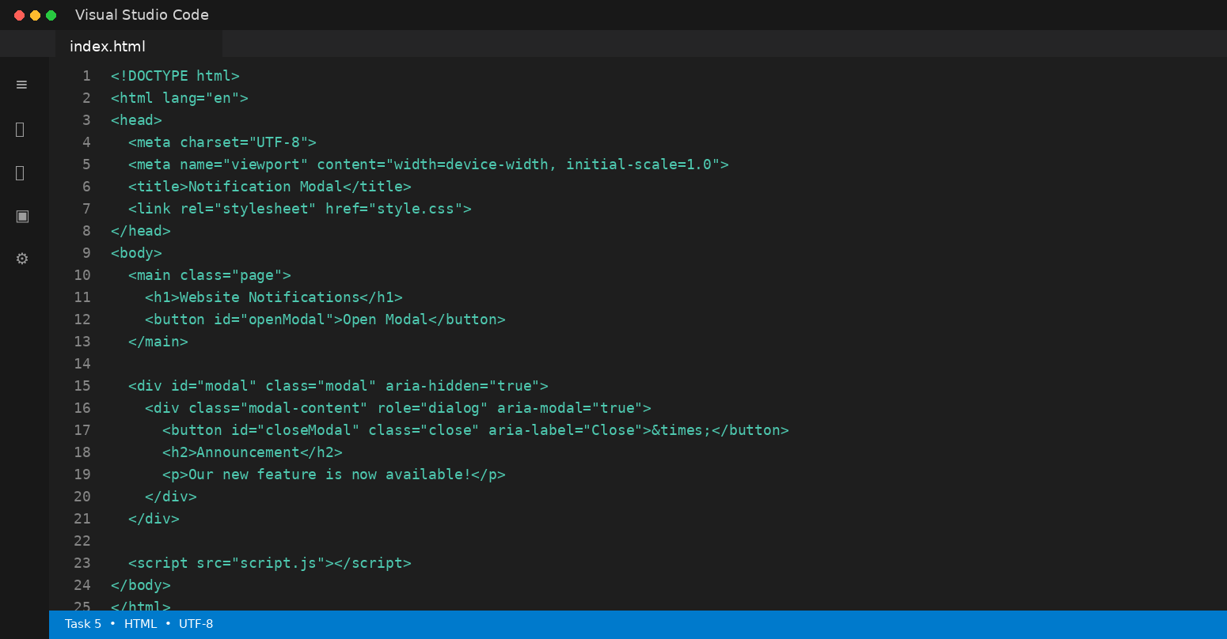
style.css
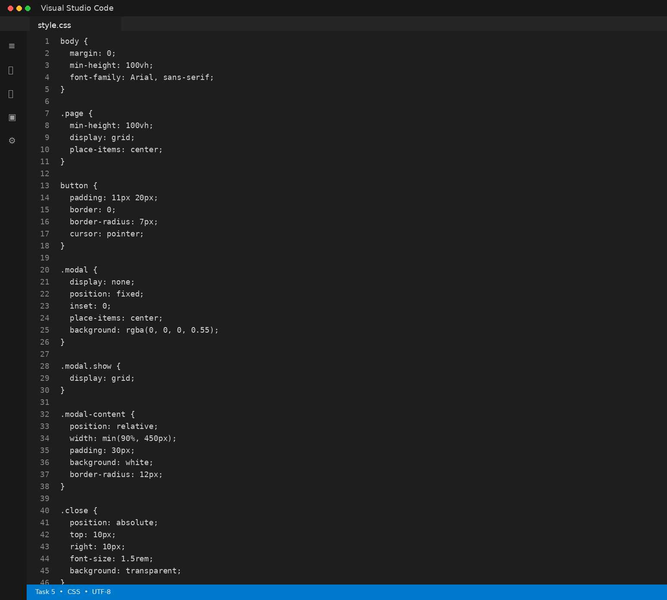
script.js
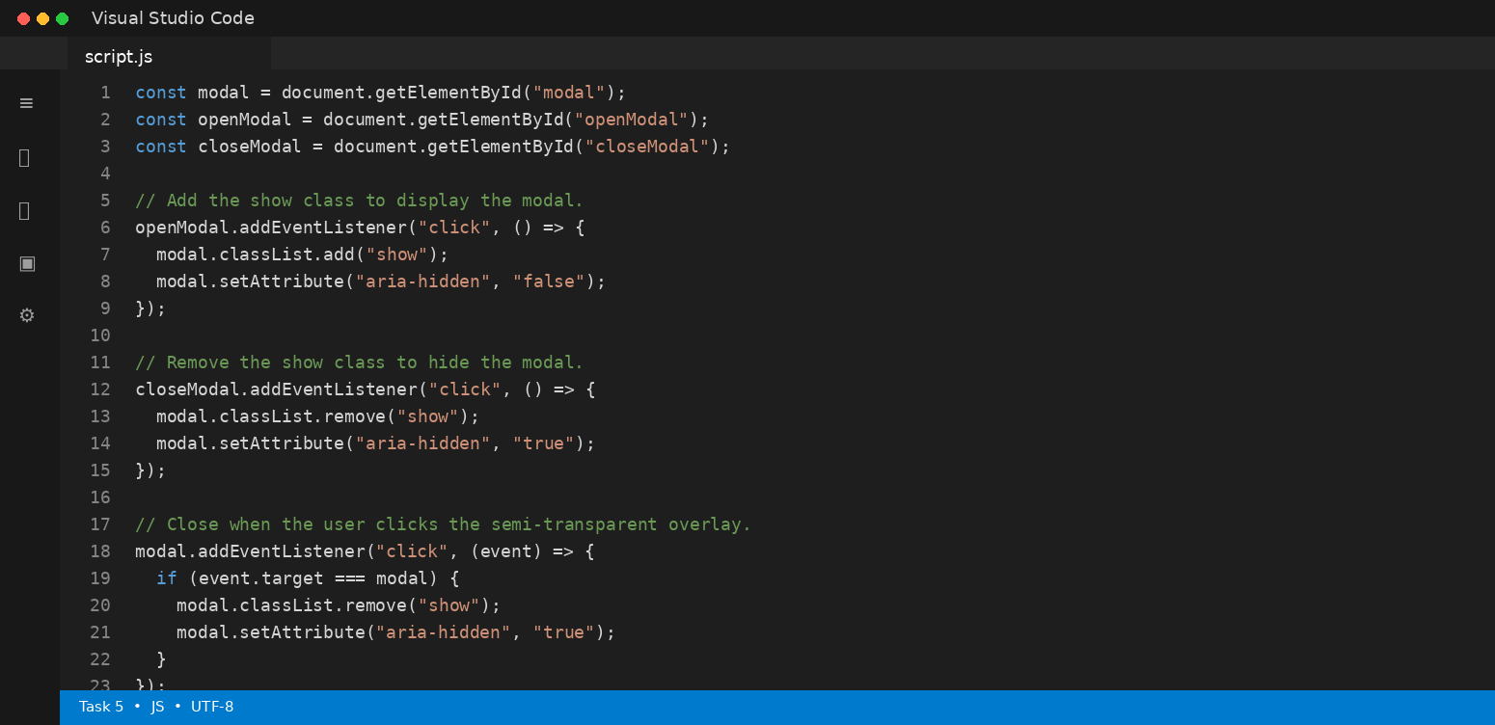
Code Explanation
The modal is hidden by default and becomes visible when the show class is added. The close button removes the class. The overlay click is checked with event.target === modal so the popup closes only when the user clicks the background outside the modal content.
Expected Output
Clicking “Open Modal” displays a notification popup over the page. It can be closed using the close button or by clicking the overlay.

Conclusion
The five tasks demonstrate AI-assisted frontend development using HTML, CSS, and JavaScript. They cover responsive design, interactive events, client-side validation, dynamic DOM manipulation, and modal notifications. The code is presented as VS Code-style screenshots so the document can be submitted as a practical lab report.

